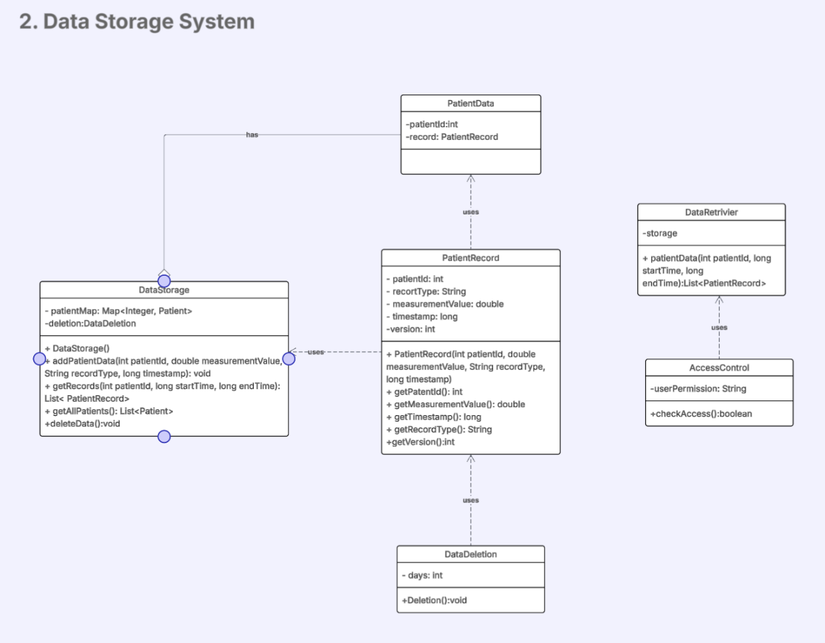

Data Storage System is designed to store and manage time-stamped patient vitals data while enabling efficient retrieval for both real-time monitoring and historical analysis. Main design components include:

**DataStorage**: serves as the central repository, using a patient ID-based mapping system to organize records chronologically. It provides methods for adding new data entries, retrieving records by patient ID and time range, and deleting outdated records.

**PatientRecord:** contains measurement values, types, and precise timestamps.

**AccessControl:** enforces permission checks, ensuring only authorized medical staff can retrieve sensitive patient data through the DataRetriever.

**DataRetriever**: uses storage to fetch records and interacts with AccessControl to verify user permissions before data access. This ensures secure retrieval by enforcing access restrictions.

**DataDeletion:** handles data deletion. Itencapsulates policies like removing records older than a specified number of days.